Public Assistance and Small Business Administration Thresholds and Individual Assistance Factors

Below is some information regarding declaration thresholds and factors for the different programs. Please let me know if you have any questions.

For Individual Assistance, FEMA has six different factors that they look at when establishing an IA declaration:
- State Fiscal Capacity and Resource Availability
- Uninsured Home and Personal Property Losses
- Disaster Impacted Population Profile
- Impact to Community Infrastructure
- Casualties
- Disaster Related Unemployment

Public Assistance Thresholds
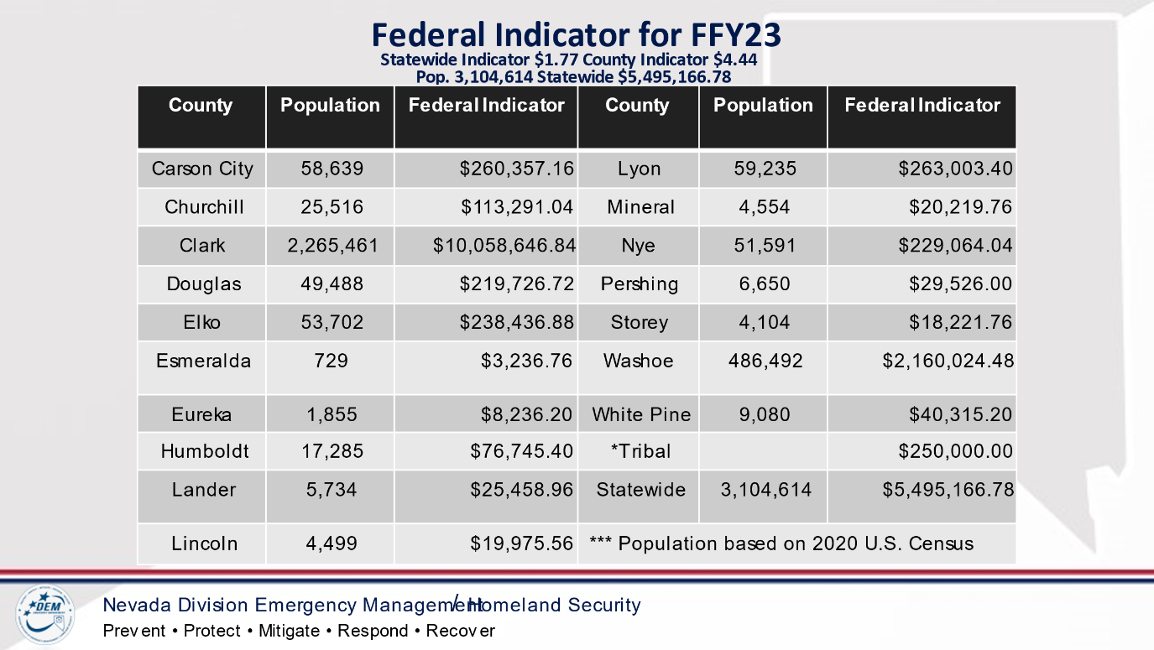

Damage Type Guidance
- Affected – Structure is habitable with slight damage to the exterior of the building. No damage to the interior of the building.
- Minor - Structure is habitable with some damage to the exterior of the building usually a water mark or debris line no higher than two feet from the ground level. Damage to the interior of the building usually includes carpeting and drywall with watermark or debris line below the electrical outlets.
- Major - Structure may be habitable moderate damage to the exterior of the building usually a water mark or debris line no higher than the doorknob and bottom window ledge. Damage to the interior of the building with watermark or debris line above the electrical outlets.
- Destroyed - Structure is inhabitable extensive damage to the exterior of the building usually a water mark or debris line higher than the door and windows.

Small Business Administration Threshold
- Low interest loans to businesses, nonprofit organizations, homeowners, and renters located in regions affected by declared disasters.
- 25 homes or businesses with uninsured losses that are greater than 40% of the value of the home or the business.
- Economic Injury Only Declarations (EIDL) for small business impacted by a disaster can be made when the Governor certifies at least 5 small business in a disaster area have suffered substantial economic injury as a result.

